Project:
Mental Health Assisstant
(Depression Detection Using DistilBERT)

Faculty of Computer Science and Info. Systems
October 6 University

Team Members:

Name | ID
Ahmed Ismail El Sayed El Sayed Azzam | 202201998

Under the Supervision of:
Dr. Reeham Gabr
1. Project Overview
This project presents a Mental Health Assistant designed to detect depression indicators in social media text. By fine-tuning the DistilBERT transformer model on a large multi-source dataset, the system classifies user-generated text as either depressive or non-depressive with high accuracy. The ultimate goal is to serve as an intelligent backbone for a conversational therapy assistant capable of identifying emotional distress in real time.

1.1 Objectives
- Build a robust binary classification model for depression detection from social media text.
- Perform thorough exploratory data analysis to uncover linguistic patterns associated with mental distress.
- Fine-tune DistilBERT on combined Reddit and Twitter datasets for optimal performance.
- Extend the system into a conversational AI therapy assistant using Ollama Llama 3.2 3B.

1.2 Workflow Summary
The project follows a structured ML pipeline:
(1) multi-source data ingestion
(2) data quality checks and cleaning
(3) exploratory data analysis
(4) text preprocessing and tokenization
(5) DistilBERT fine-tuning with early stopping
(6) evaluation on a held-out test set and an external dataset
(7) integration with a conversational LLM for deployment as a therapy assistant.

2. Data Summary and Description
Three publicly available datasets were sourced from Kaggle and combined to create a rich, diverse corpus for model training. The datasets span two major social media platforms Reddit and Twitter ensuring the model learns from varied writing styles, vocabularies, and expression patterns.

2.1 Source Datasets

Dataset | Source | Rows | Class Balance
Dataset 1 | Reddit (infamouscoder)  Kaggle link | 7,731 | Not Depression: 3,900 Depression: 3,831
Dataset 2 | Twitter Train (samrats)  Kaggle link | 31,000 | Not Depression: 15,000 Depression: 16,000
Dataset 3 | Twitter Test (samrats)  Kaggle link | 31,000 | Not Depression: 15,000 Depression: 16,000

2.2 Data Quality Overview

Dataset | Missing Values | Duplicate Rows
Reddit Dataset | None | 81 rows
Twitter Train | None | 932 rows
Twitter Test | None | 1,956 rows

2.3 Combined Dataset
After concatenating the three datasets and standardising column names to 'text' and 'label', the combined dataset contained 69,731 rows. Following the removal of 2,969 duplicate records, the final cleaned dataset comprised 66,762 unique text samples with a near-balanced class distribution.
Metric | Value
Total Rows (raw) | 69,731
Duplicate Rows Removed | 2,969
Final Unique Rows | 66,762
Not Depressed (Label 0) | ~35,000 (~52%)
Depressed (Label 1) | ~32,000 (~48%)
3. Data Cleaning Steps
A multi-step data cleaning pipeline was applied to ensure data quality and model readiness. Each step was deliberately designed to preserve emotional signal while removing noise.

3.1 Duplicate Removal
Exact duplicate rows were identified and removed. A total of 2,969 duplicate entries were found across the combined dataset. Removing duplicates prevents the model from over-fitting to repeated patterns and ensures each training sample contributes uniquely to learning.

3.2 Text Preprocessing for Modeling
A dedicated clean_text() function was applied to all text samples prior to training:
- URL Removal: All HTTP/HTTPS URLs were stripped using re.sub(r"http\S+", "", text) to eliminate irrelevant hyperlinks that carry no semantic value.
- HTML Tag Removal: Residual HTML markup was removed using re.sub(r"<.*?>", "", text) to clean any web-scraped artefacts.
- Whitespace Normalisation: Multiple consecutive spaces and tabs were collapsed to single spaces and leading/trailing whitespace was trimmed.

3.3 Train / Validation / Test Split
The cleaned dataset was split into three stratified subsets to ensure each partition maintains the same class distribution as the full dataset:

Split | Size | Proportion | Purpose
Training Set | 46,733 | 70% | Model fine-tuning
Validation Set | 10,014 | 15% | Hyperparameter tuning & early stopping
Test Set | 10,015 | 15% | Final unbiased evaluation

4. Exploratory Data Analysis (EDA)
A comprehensive EDA was conducted to understand the dataset's structure, uncover linguistic patterns, and validate the suitability of the data for binary classification. The analysis covers class distribution, text length and word count, frequent word patterns, and special character usage.

4.1 Class Distribution
Plot: Bar Chart Class Distribution
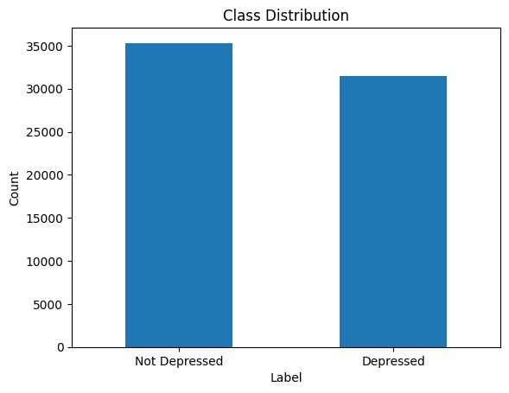

Insight:
- The dataset is well-balanced, with approximately 35,000 samples labelled as Not Depressed and 32,000 labelled as Depressed.
- The near-even class split (~52% vs 48%) is ideal for binary classification as it prevents the model from biasing towards a majority class.
- Because the classes are balanced, Accuracy is a reliable primary metric. In an imbalanced setting, F1-score or AUC would be preferred.

4.2 Text Length Distribution
Plot: Histogram Tweet / Post Length Distribution by Class
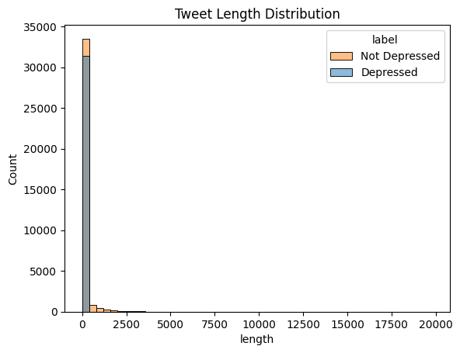

Insight:
- Both classes are heavily right-skewed, meaning the vast majority of posts are under 500 characters typical of social media data.
- The Depressed class shows a notable long tail, with some posts exceeding 10,000–20,000 characters, representing long-form venting or detailed personal narratives.
- Since DistilBERT has a 128-token maximum, long posts are truncated. The first 128 tokens are generally sufficient to capture the emotional tone.

4.3 Word Count per Label

Plot: Box Plot — Word Count per Labe
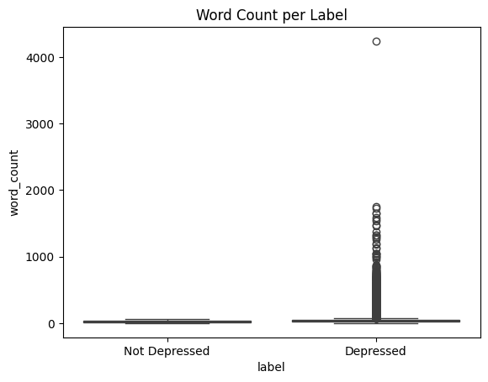

Insight:

The median word count is low and similar for both classes, indicating that the average post in both categories is concise.

The Depressed class shows a dramatically wider distribution of outliers, with some posts exceeding 4,000 words a pattern absent in the Not Depressed class.

This confirms the 'venting phenomenon': individuals expressing depressive symptoms disproportionately use social media for extended personal storytelling.

4.4 Word Frequency Analysis & Word Clouds

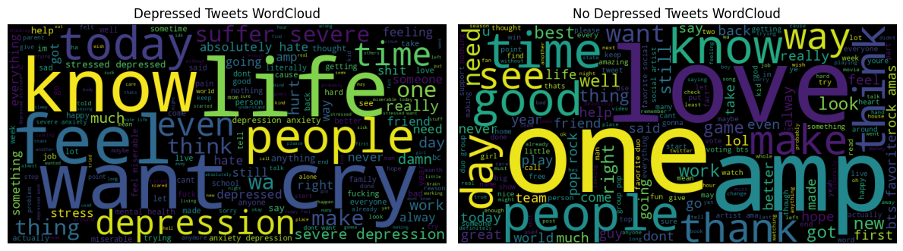
Plot: Word Clouds Depressed vs. Not Depressed Classe

Insight:

Depressed class: dominated by high-intensity emotional tokens such as depression, cry, suffer, miserable, and severe reflecting strong internal distress and unmet emotional needs.

Not Depressed class: characterised by positive, outward-looking vocabulary including love, good, thank, favorite, and best, indicating social engagement and positive affect.

Shared words such as time and people appear in both clouds but carry entirely different contextual meanings 'struggling all the time' versus 'having a good time.'

5. Modeling
The modeling phase involved converting the cleaned dataset into HuggingFace Dataset objects, tokenising the text using the DistilBERT tokenizer, and fine-tuning the pre-trained model for binary sequence classification.

5.1 Model Architecture
DistilBERT (distilbert-base-uncased) was selected as the backbone model. It is a distilled version of BERT that retains 97% of its language understanding capability while being 40% smaller and 60% faster. It was adapted for binary sequence classification by appending a linear classification head.
5.2 Tokenisation
Texts were tokenised using the AutoTokenizer for distilbert-base-uncased with the following settings:
- Truncation: True long texts are truncated to the maximum length.
- Padding: max_length all sequences are padded to a uniform length of 128 tokens.
- Max Length: 128 tokens sufficient for the vast majority of social media posts.

5.3 Training Results per Epoch

The best model checkpoint was saved at Epoch 4 (highest F1 = 99.53%).
Epoch | Train Loss | Val Loss | Accuracy | F1 | Precision | Recall
1 | 0.0852 | 0.0529 | 99.40% | 99.43% | 99.64% | 99.23%
2 | 0.0422 | 0.0596 | 99.38% | 99.41% | 99.49% | 99.34%
3 | 0.0173 | 0.0579 | 99.41% | 99.44% | 99.42% | 99.47%
4 | 0.0035 | 0.0683 | 99.50% | 99.53% | 99.58% | 99.47%
5 | 0.0010 | 0.0794 | 99.48% | 99.51% | 99.55% | 99.47%

6. Evaluation Results
6.1 Internal Test Set Performance
The saved best model was evaluated on the 10,015 held-out test samples that were never seen during training or validation:

Metric | Not Depressed | Depressed | Overall
Precision | 0.99 | 1.00 | 0.99
Recall | 0.99 | 0.99 | 0.99
F1-Score | 0.99 | 0.99 | 0.99
Support | 4,716 | 5,299 | 10,015
Accuracy | — | — | 99.39%

6.2 Confusion Matrix Internal Test Set
Plot: Confusion Matrix Internal Test Set
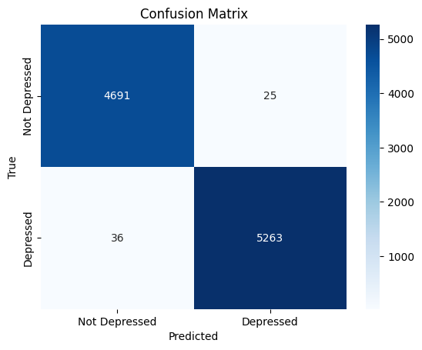

The confusion matrix shows only 25 false positives and 36 false negatives out of 10,015 predictions, demonstrating exceptional discrimination between the two classes.

6.3 External Dataset Validation (Kaggle link)
To assess real-world generalisation, the model was evaluated on an independent external dataset (Suchintika Sarkar / Sentiment Analysis for Mental Health), which was not part of the original training pipeline:

Metric | Not Depressed (Normal) | Depressed (Depression) | Overall
Precision | 0.97 | 0.88 | 0.92
Recall | 0.88 | 0.97 | 0.92
F1-Score | 0.92 | 0.92 | 0.92
Support | 16,351 | 15,404 | 31,755
Accuracy | — | — | 92.16%

6.4 Confusion Matrix External Dataset
Plot: Confusion Matrix External Dataset
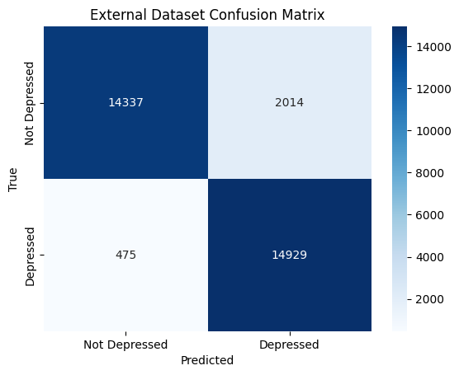

Insight:
To verify the model's generalizability, it was evaluated on an external dataset. While accuracy dropped from 99% to 92.1%, the model maintained a high Recall of 0.97 for the Depression class. This indicates that the model is highly effective at identifying depressive signals across different data sources, though it tends toward 'over-sensitivity' (False Positives) when analyzing normal everyday stress.
7. Enhancement: Chatbot with Ollama Llama 3.2 3B
To transform the depression detection model into a fully interactive mental health assistant, the project is extended with a conversational AI layer powered by Ollama's locally-hosted Llama 3.2 3B model. This creates a two-stage pipeline: first classify the user's emotional state, then respond with contextually appropriate, empathetic dialogue.
7.1 System Architecture
The enhancement introduces a dual-component pipeline:
- Stage 1 Classifier: The fine-tuned DistilBERT model analyses the user's input and predicts a depression risk label (0 = Not Depressed, 1 = Depressed).
- Stage 2 Conversational LLM: Based on the classifier's output, a dynamically constructed system prompt is fed to the Llama 3.2 3B model via Ollama's local API, generating a therapeutic, empathetic response.

